**FS Assignment-3**

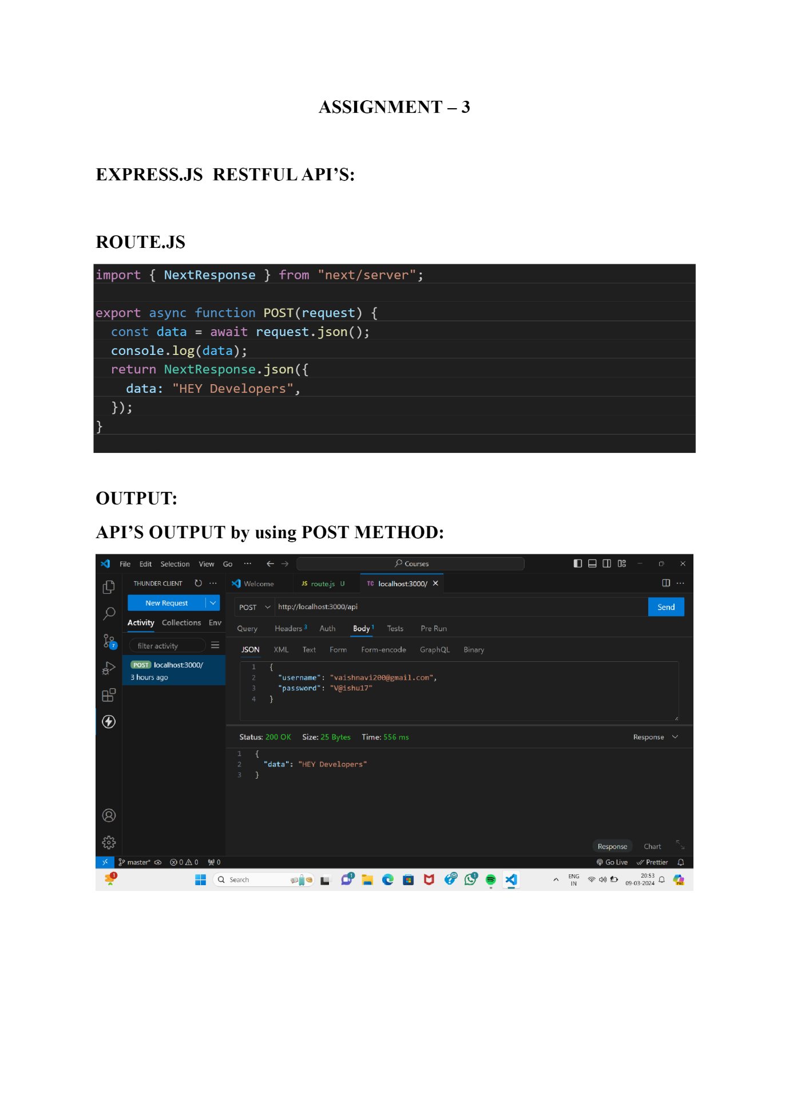

**DATABASE CREATION USING MONGODB:**

Adding the database into the data:

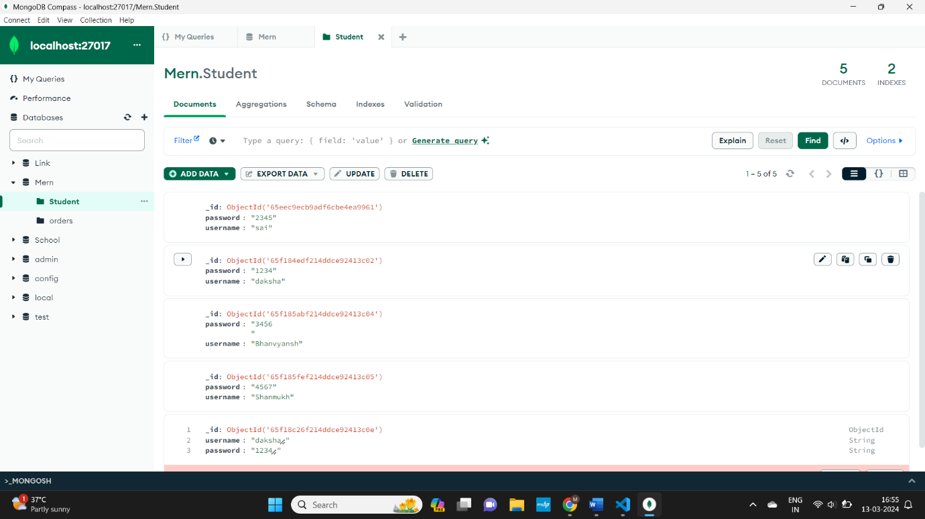

**INDEXES:**

When we create or add data into database, we use indexes not to allow duplicates in it.

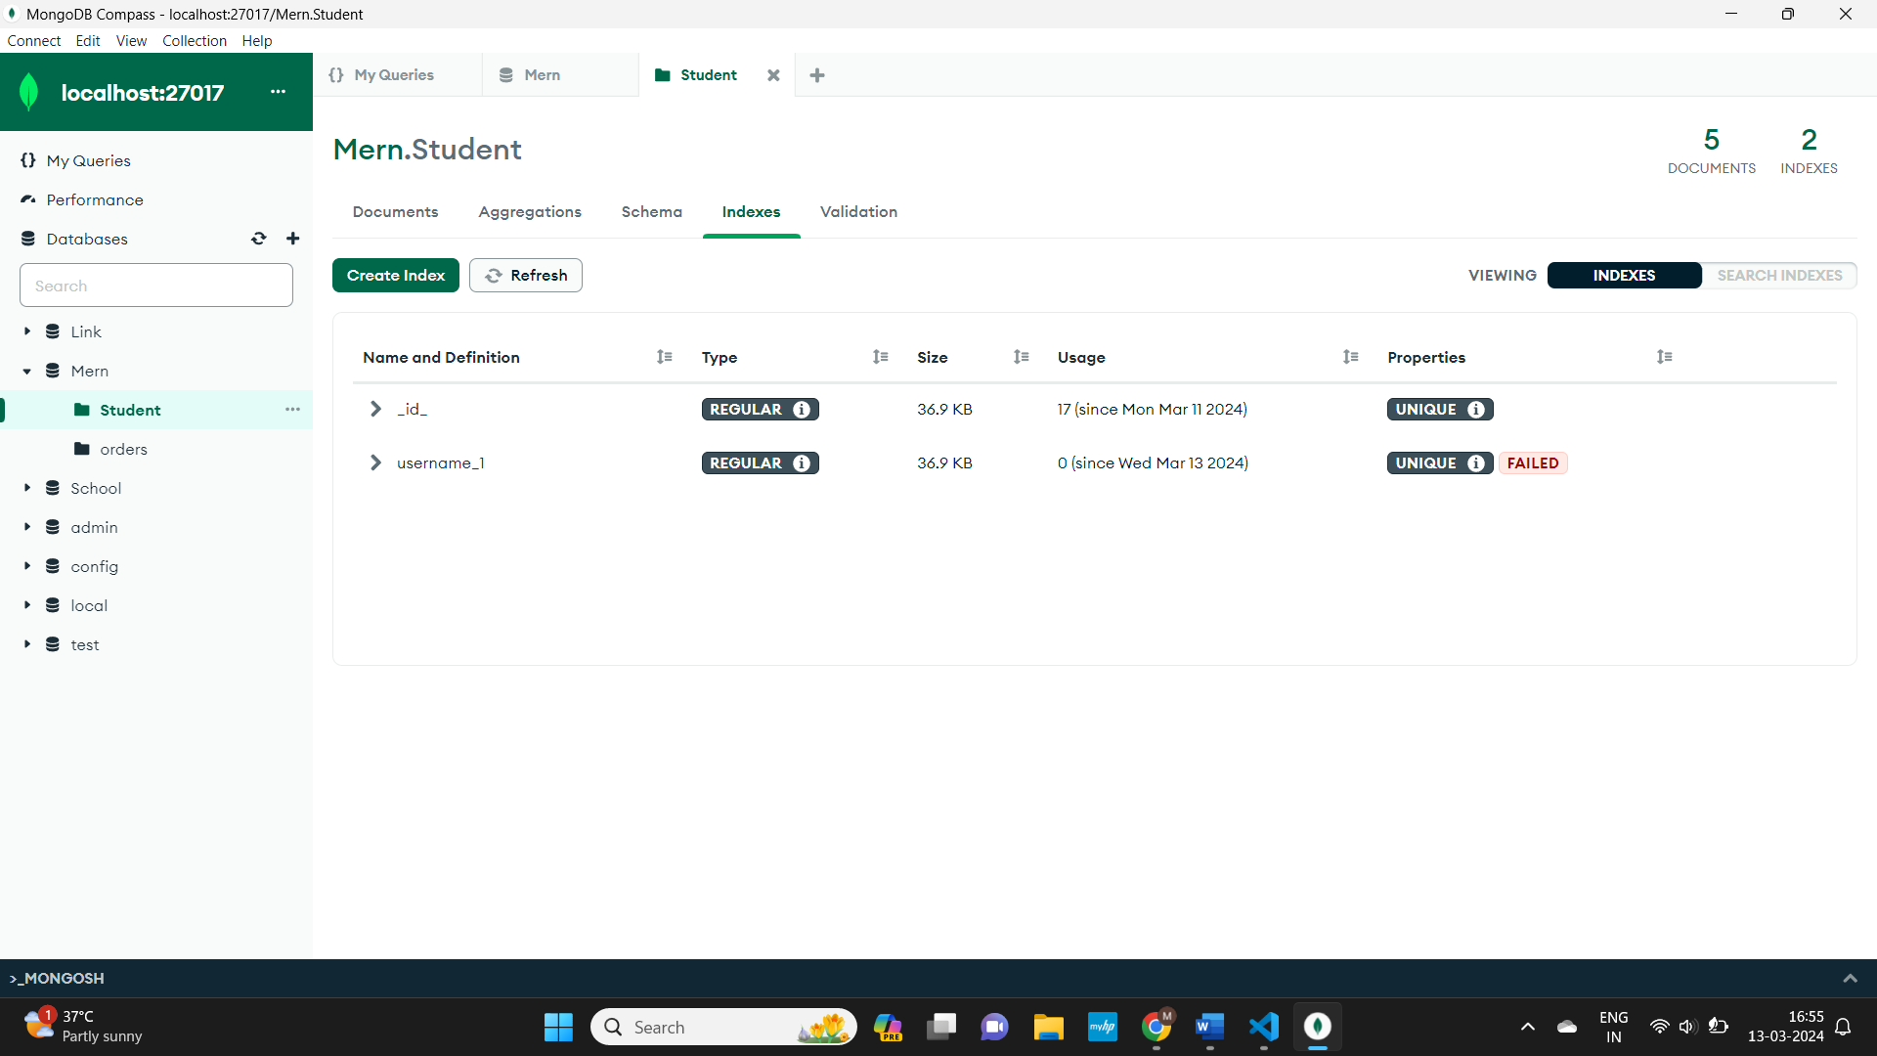

If the same data is been given it shows error as duplicate cannot be taken.

